**Christopher King**

**2018141521058**

**Applied Fluid Mechanics**

**Class Section 01**

**06/16/2021**

# **Problem 12.63**

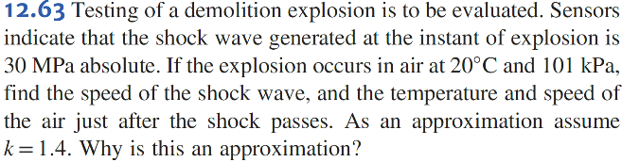

**Solution:**

# **Problem 12.67**

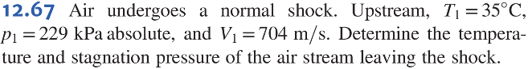

**Solution:**

# **Problem 12.68**

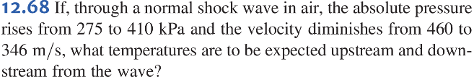

**Solution:**

# **Problem 12.71**

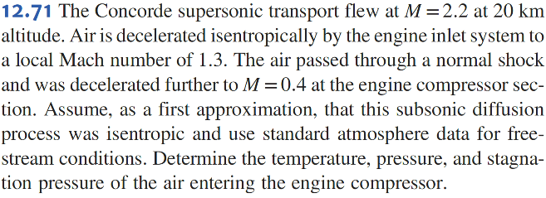

**Solution:**

For ,

For ,

For ,